FemSense AI: Early Detection of Women’s Reproductive Disorders Using Multimodal Deep Learning

R. Bavadhaarini (E0324001)
Dept. of Artificial Intelligence and Data Analytics
Sri Ramachandra Faculty of Engineering and Technology Sri Ramachandra Institute of Higher Education and Research
Porur, Chennai, Tamil Nadu, India

Guided By: Guide Name
Dept. of Artificial Intelligence and Data Analytics
Sri Ramachandra Faculty of Engineering and Technology Sri Ramachandra Institute of Higher Education and Research
Porur, Chennai, Tamil Nadu, India

Abstract—Polycystic ovary syndrome (PCOS), endometriosis and adenomyosis are common reproductive disorders in women. Their symptoms overlap, so diagnosis is often delayed by years. Most computational studies use either imaging or clinical data alone, and few explain their predictions. This paper presents FemSense AI, a multimodal deep learning framework that fuses ultrasound/MRI images with 14 clinical and hormonal features to classify a patient as Normal, PCOS, Endometriosis or Adeno-myosis. The same network also predicts a four-level severity grade and a continuous risk score. A ResNet18 encoder processes the image, a dense network encodes the clinical record, and the two feature vectors are concatenated and passed through a shared fusion layer into three task-specific heads trained with a weighted multi-task loss. To support clinical trust, the system provides Grad-CAM heat maps for the image branch and gradient-times-input attribution for the clinical branch, and is delivered as a Streamlit web application. The framework was developed and evaluated on a synthetic dataset of 800 samples, which allows the full pipeline to be reproduced without patient data. On a held-out test split it achieved 00.0% disease accuracy, 00.0% severity accuracy and a risk-score MAE of 0.000. These figures demonstrate the pipeline, not clinical performance. Validation on real, ethically approved patient data is the main direction for future work.
Index Terms—Multimodal deep learning, PCOS, endometrio-sis, adenomyosis, ResNet18, transfer learning, Grad-CAM, ex-plainable AI, clinical decision support.

- Introduction
Polycystic ovary syndrome (PCOS), endometriosis and ade-nomyosis are among the most common causes of pelvic pain, menstrual disturbance and infertility in women of reproductive age [5]–[7]. They share symptoms such as pain, irregular or heavy bleeding and subfertility, which makes them easy to confuse in routine consultations. Endometriosis in particular is known for long diagnostic delays [6]. Early detection matters because timely treatment reduces symptoms, protects fertility and lowers long-term risk.

Lishalini M (E0324002)
Dept. of Artificial Intelligence and Data Analytics
Sri Ramachandra Faculty of Engineering and Technology Sri Ramachandra Institute of Higher Education and Research
Porur, Chennai, Tamil Nadu, India

In practice, clinicians reach a diagnosis by combining several sources of evidence: the patient’s history and symp-tom scores, laboratory hormone values, and imaging such as transvaginal ultrasound or MRI. Deep learning has shown strong results on medical image analysis [12], but a model that sees only the image ignores the symptoms and hormones a clinician would weigh. A model that sees only tabular data ignores the anatomical findings. Multimodal learning, which fuses information from different modalities, is a natural fit for this problem [3].
Two further issues limit the adoption of such systems. First, a black-box prediction is hard for a clinician to trust. Second, a single diagnosis label is less useful than a label accompanied by a severity grade and a risk estimate that can guide follow-up urgency.
The main contributions of this paper are:

- A multimodal network that fuses a ResNet18 image encoder with a dense clinical encoder to classify Normal, PCOS, Endometriosis and Adenomyosis.
- A multi-task design that predicts disease, four-level severity and a continuous risk score from one shared representation.
- Built-in explainability: Grad-CAM for the image branch and gradient-times-input attribution for the clinical fea-tures.
- A reproducible end-to-end pipeline (data generation, training, evaluation, inference and a Streamlit demo) that runs on a CPU.
- A rule-based recommendation layer that maps the pre-dicted disease, severity and risk into follow-up advice, framed as decision support.



- Literature Review
Ultrasound / MRI image (128×128)
Clinical data (14 features)
ResNet18 (512-d)
Dense NN (32-d)
Concatenate (544-d) + Fusion MLP (128)
Severity Disease
(4 classes) (4 classes)
Risk (0–1)
Grad-CAM, clinical attribution, recommendation

  - Deep Learning in Medical Imaging
Convolutional neural networks (CNNs) have become the standard approach for medical image classification, segmen-tation and detection [12]. Residual networks such as ResNet introduced skip connections that make deeper models trainable [1]. Because labelled medical datasets are small, transfer learning, where a network pretrained on a large natural-image dataset is adapted to the target task, is widely used to improve accuracy and reduce training time [8].

  - Multimodal Learning
Multimodal machine learning combines data from different sources to build a richer representation than any single modal-ity provides [3]. Fusion strategies are commonly grouped into early fusion (combining raw inputs), late fusion (combining per-modality decisions) and intermediate fusion (combining learned feature vectors). FemSense AI uses intermediate fusion by concatenating the learned image and clinical feature vectors before a shared fusion layer.

  - Multi-Task Learning
Training one network on several related tasks lets the tasks share a representation, which can act as a regulariser and improve generalisation [4]. Here, disease classification, severity grading and risk estimation are closely related clinical questions and are learned jointly.

  - Explainable AI for Clinical Use
Grad-CAM uses the gradients flowing into the last convo-lutional layer to produce a heat map showing which image regions support a prediction [2]. For tabular inputs, gradient-based attribution methods such as gradient-times-input esti-mate how much each feature contributed to an output [11]. Providing both helps a clinician check whether a prediction rests on plausible evidence.

  - Research Gaps
    - Many studies address a single disorder, whereas the three conditions overlap clinically and should be distinguished together.
    - Many models use only images or only tabular data, and so do not mirror how clinicians combine evidence.
    - Few systems provide severity and risk outputs alongside the diagnosis.
    - Explainability is often missing or limited to the image.
    - Research code is often hard to reproduce and lacks a usable interface.
FemSense AI is designed to address these gaps in a single, reproducible framework.

Fig. 1. Overall architecture of FemSense AI: two encoders, a shared fusion layer, three task heads and an explainability/recommendation stage.

- Proposed System
- Overview
FemSense AI accepts two inputs for each patient: an ultra-sound or MRI image and a clinical record of 14 features. It re-turns (i) a predicted condition (Normal, PCOS, Endometriosis or Adenomyosis), (ii) a severity grade (None, Mild, Moderate or Severe), (iii) a risk score between 0 and 1 with a risk level,
(iv) visual and numerical explanations, and (v) a follow-up recommendation. The overall architecture is shown in Fig. 1.
- Clinical Features
The clinical branch uses 14 inputs: age, BMI, cycle length (days), pelvic pain score, dysmenorrhea score, heavy bleeding (yes/no), hirsutism score, acne (yes/no), infertil-ity (yes/no), family history (yes/no), anti-Mu¨llerian hormone (AMH), LH/FSH ratio, testosterone and CA-125. They were chosen because they are associated with the three conditions: for example, an elevated LH/FSH ratio, raised AMH and hirsutism with PCOS; severe pelvic pain, dysmenorrhea and raised CA-125 with endometriosis; and heavy bleeding with adenomyosis.
- Output Definitions
Disease is a four-class label. Severity is a four-class label where “None” applies only to Normal cases. The risk score is a continuous value in [0, 1]. During training each severity grade is mapped to a target risk value (None 0.05, Mild 0.35, Moderate 0.65, Severe 0.95). At inference the risk score is converted to a level: Low (< 0.25), Moderate (0.25 to < 0.55), High (0.55 to < 0.80) or Very high (≥ 0.80).
- System Architecture
- Image Branch
The image encoder is a ResNet18 [1] with its final classi-fication layer removed, so that it outputs a 512-dimensional feature vector. Images are converted to three channels and resized to 128 × 128 pixels. The implementation can start from ImageNet-pretrained weights (transfer learning [8]) or

from random initialisation, controlled by a configuration flag. The reported experiments used ImageNet-pretrained weights.
- Clinical Branch
The 14 clinical features are standardised (zero mean, unit variance) using a scaler fitted on the training set only. They pass through a dense network: Linear(14→64), ReLU, Dropout(0.2), Linear(64→32), ReLU, producing a 32-dimensional vector.
- Fusion and Task Heads
The 512-d image vector and the 32-d clinical vector are concatenated (544-d) and passed through a fusion layer: Linear(544→128), ReLU, Dropout(0.3). Three linear heads

- Dataset

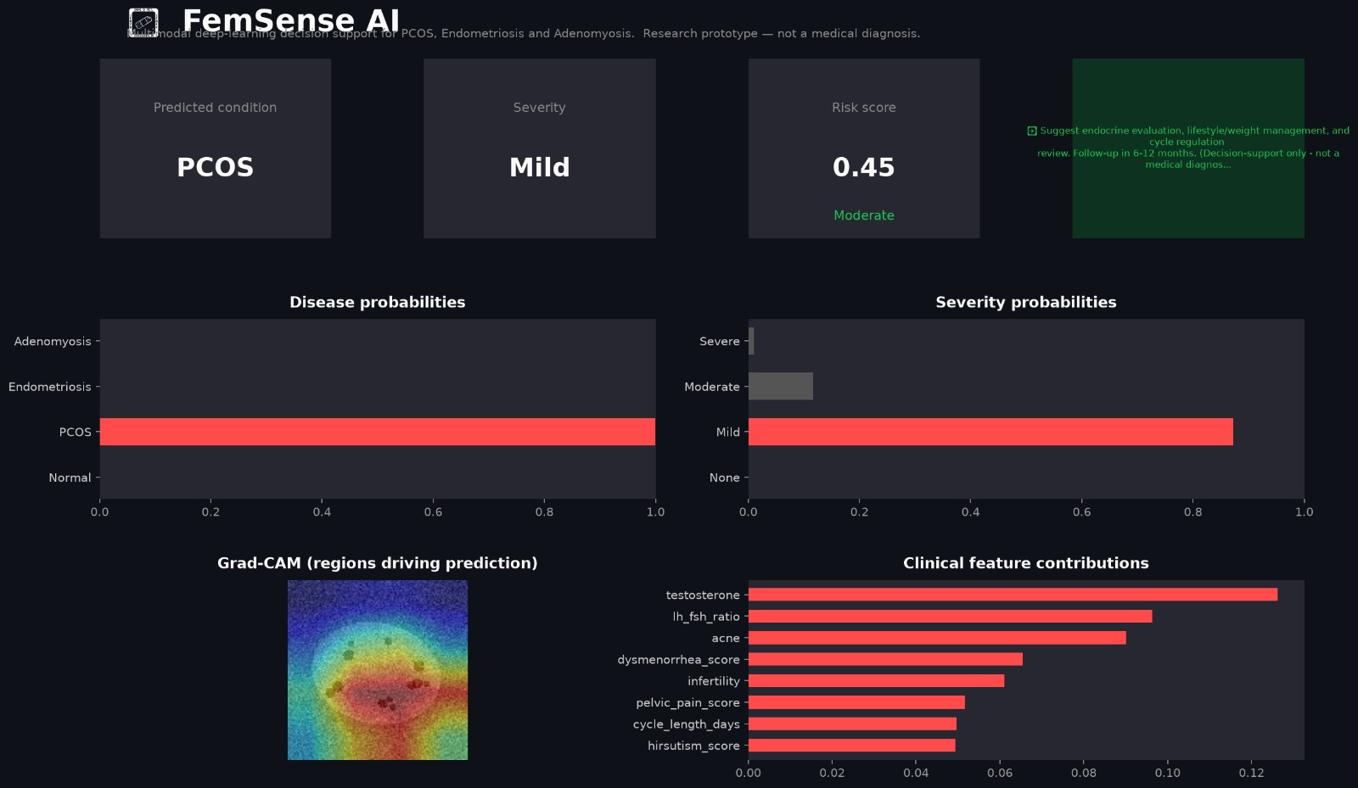
Fig. 2. Streamlit dashboard of FemSense AI.

- Methodology

read this shared 128-d representation: a disease head with 4 outputs, a severity head with 4 outputs, and a risk head with 1 output passed through a sigmoid.
- Multi-Task Loss
The network is trained with a weighted sum of three losses:
L = Ldisease + 0.5 Lseverity + 0.5 Lrisk, (1)
where L_{disease} and L_{severity} are cross-entropy losses and L_{risk} is binary cross-entropy between the predicted risk and the target risk value. Disease is weighted most heavily because it is the primary task.
- Explainability Module
Grad-CAM (image). Gradients of the selected disease logit are taken with respect to the activations of the last residual block (layer4). They are averaged over space to obtain channel weights, the weighted activations are summed, a ReLU is applied, and the map is up-sampled to the image size and normalised to [0, 1] [2]. The heat map is overlaid on the input image.
Clinical attribution. For the same disease logit, the gradient with respect to the standardised clinical input is multiplied by the input itself (gradient × input) [11]. The result is a signed score per feature, showing which clinical values pushed the prediction towards or away from the predicted class.
- Recommendation Layer
A rule-based layer maps the predicted disease to a suggested clinical step (for example, endocrine evaluation and lifestyle review for PCOS, or gynaecological review and MRI follow-up for endometriosis) and the severity to a follow-up window (6 to 12 months for Mild, within 1 to 3 months for Moderate, prompt consultation for Severe). Every message states that the output is decision support and not a medical diagnosis.
- Web Application
The system is delivered as a Streamlit application. A user uploads an image (or loads a sample patient), enters or edits the 14 clinical values, and receives the predicted condition, severity, risk score, probability bar charts, the Grad-CAM overlay, the top clinical attributions and the recommendation (Fig. 2).
Real ultrasound and MRI data for these conditions are patient-sensitive and require ethics approval. To make the pipeline reproducible without patient data, a synthetic data generator was used. It produces 800 samples, each with a 128 × 128 grayscale ultrasound-like image and a correlated clinical record. The disease for each sample is drawn at random and severity (1 to 3) is drawn for abnormal cases. Image patterns mimic characteristic findings: multiple small follicle-like dark spots around the ovary for PCOS (the number increases with severity); a large ground-glass cyst with a bright rim for endometriosis (the size increases with severity); and a heterogeneous, enlarged uterine wall with linear dark streaks for adenomyosis. Speckle noise is added to all images. Clinical values are sampled from distributions that depend on the disease and severity, e.g. higher LH/FSH ratio, AMH, testosterone and hirsutism for PCOS; higher pelvic pain, dysmenorrhea and CA-125 for endometriosis; and frequent heavy bleeding with older age for adenomyosis.
The generated class distribution is Normal 206, PCOS 172, Endometriosis 210 and Adenomyosis 212. Among abnormal cases, severity is spread roughly evenly across Mild, Moderate and Severe.
Limitation: because both the images and the clinical fea-tures were generated by rules written by the authors, a network can learn those rules easily. High accuracy on this dataset therefore shows that the pipeline works. It is not evidence of clinical accuracy.
- Data Split and Pre-processing
The data were divided into 70% training (560), 15% valida-tion (120) and 15% test (120) samples. The split is stratified by disease class with a fixed random seed of 42. Images are resized to 128 × 128 and normalised with ImageNet mean and standard deviation. Training images receive random horizontal flips and random rotations of up to 10 degrees. Validation and test images are not augmented.
- Training Configuration
The model was implemented in Python with PyTorch [9] and trained with the Adam optimiser [10] at an initial learning rate of 10⁻³, a batch size of 32 and 12 epochs. A step scheduler halves the learning rate every 5 epochs. After each

TABLE I
Training Hyper-parameters
TABLE III
Overall Test-Set Performance

Parameter Value

Image size 128 × 128
Batch size 32
Epochs 12
Optimiser Adam
Initial learning rate 10⁻³
LR schedule Halved every 5 epochs Loss weights (disease:severity:risk) 1 : 0.5 : 0.5
Dropout (clinical / fusion) 0.2 / 0.3
Random seed 42
Pretrained weights Yes
Task Metric Result

Disease (4 classes) Accuracy 00.0%
Severity (4 classes) Accuracy 00.0% Risk score MAE 0.000

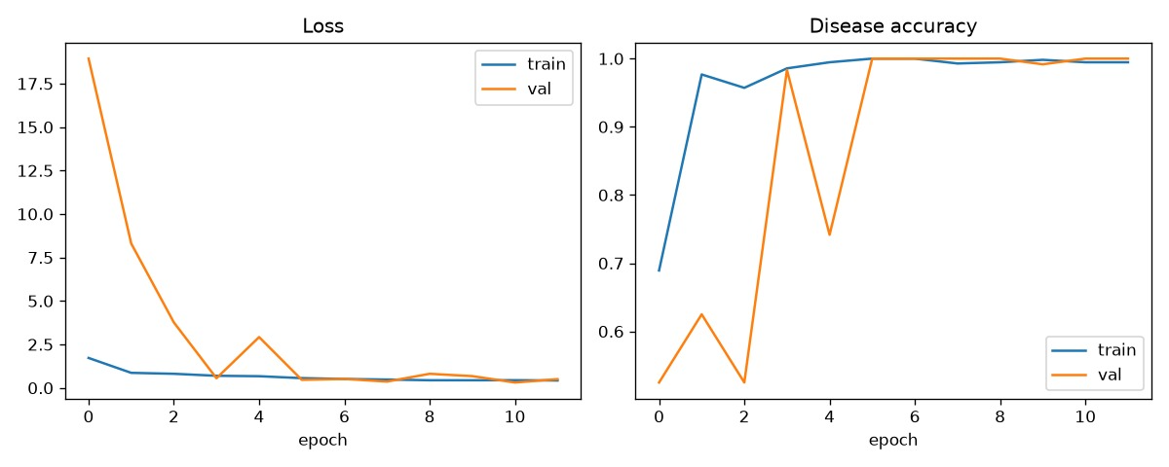
TABLE II
Technology Stack

Component Technology

Language Python 3.9–3.12
Deep learning PyTorch, torchvision (ResNet18)
Data handling NumPy, pandas, Pillow Pre-processing and metrics scikit-learn Visualisation Matplotlib
Web interface Streamlit
Development VS Code, Git

epoch the model is evaluated on the validation set and the checkpoint with the best validation disease accuracy is kept. Training ran on a CPU in about 10 minutes. Table I lists the settings.
- Evaluation Metrics
Disease and severity are evaluated with accuracy, per-class precision, recall and F1-score, and confusion matrices. The risk score is evaluated with the mean absolute error (MAE) against the severity-derived target. All metrics are computed on the held-out test set.
- Inference Workflow
For a new patient, the image is pre-processed, the clinical values are standardised with the saved scaler, and both are passed through the network to obtain disease probabilities (softmax), severity probabilities (softmax) and a risk score (sigmoid). Grad-CAM and clinical attribution are then com-puted for the predicted class, and the recommendation layer produces the advice text.
- Implementation
The system is implemented in Python (Table II). The code is organised into separate modules: configuration, synthetic data generation, dataset and transforms, model definition, training, evaluation, inference with explainability, and a command-line demo. Real clinical data can be used by supplying a CSV file with the 14 clinical columns, an image path, a disease label and a severity label, without changing the model code.
- Experimental Results and Analysis
All results are on the held-out test set of 120 samples.

Fig. 3. Training and validation loss and disease accuracy.

TABLE IV
Per-Class Disease Results on the Test Set

Class | Precision | Recall | F1 | Support
Normal | 0.00 | 0.00 | 0.00 | 0
PCOS | 0.00 | 0.00 | 0.00 | 0
Endometriosis | 0.00 | 0.00 | 0.00 | 0
Adenomyosis | 0.00 | 0.00 | 0.00 | 0
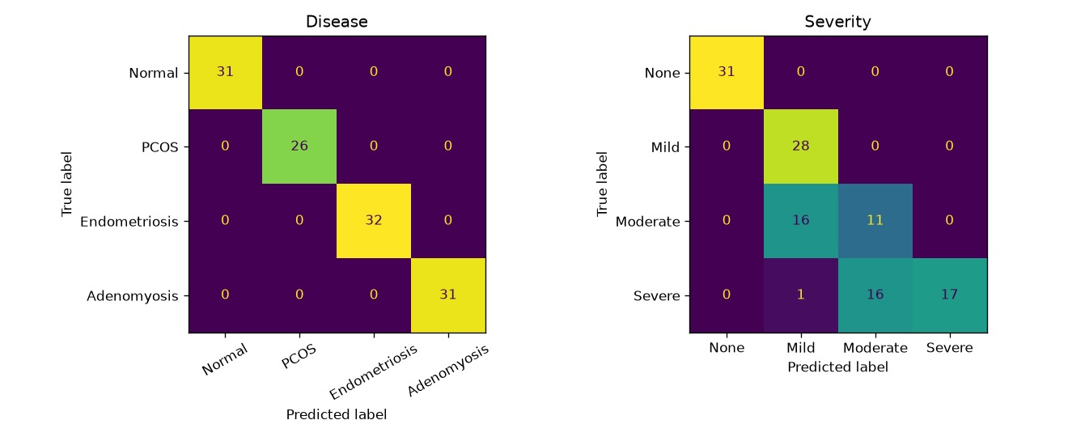
Fig. 4. Confusion matrices for disease (left) and severity (right).

- Overall Performance
Table III summarises the test-set performance. Training and validation curves are shown in Fig. 3.
- Per-Class Disease Results
Table IV gives precision, recall and F1-score for each disease class, and Fig. 4 shows the confusion matrices for disease and severity.
- Discussion of Results
The model reached 00.0% disease accuracy and 00.0% severity accuracy on the test set. Any remaining disease errors are most plausibly between Endometriosis and Adenomyosis, since both are characterised by pelvic pain, dysmenorrhea and heavy bleeding, and the confusion matrices in Fig. 4 show exactly where the errors fall. Severity is a finer-grained task than disease, because adjacent grades differ only in the amount of a pattern (the number of follicles or the size of

TABLE V
Ablation: Contribution of Each Modality

Variant | Disease acc. (%) | Severity acc. (%)
Image only (ResNet18) | 00.0 | 00.0
Clinical only (dense NN) | 00.0 | 00.0
Fused (proposed) | 00.0 | 00.0
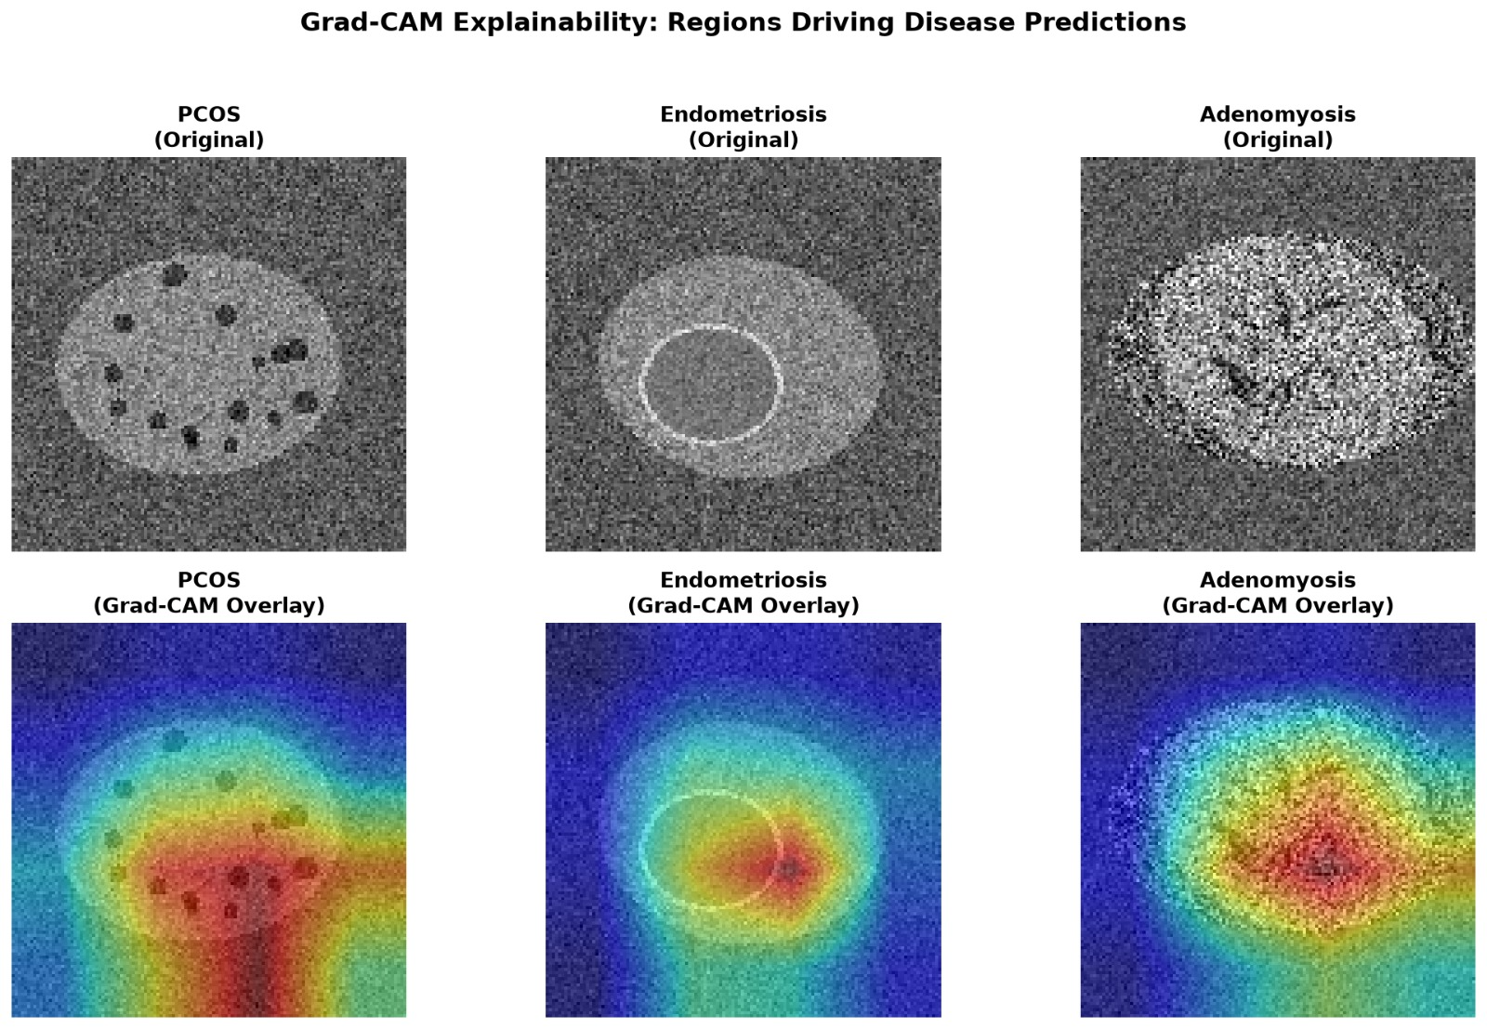
Fig. 5. Grad-CAM overlays for example patients.

a cyst), so it is generally expected to be at least as hard as disease classification. The curves in Fig. 3 show how closely training and validation performance track each other over the 12 epochs. Because the data are synthetic and rule-generated, strong results here mainly confirm that the pipeline is correct and should not be read as expected clinical accuracy.
- Ablation Study
The central claim of this paper is that fusing both modalities is better than using either alone. To test it, three variants were trained and evaluated under identical settings (Table V). Be-cause the synthetic data are highly separable, single-modality variants may also score close to the fused model. If so, that is a further sign that the data are too easy, and it means this ablation cannot by itself prove the benefit of fusion on real data.
- Explainability Results
Fig. 5 shows Grad-CAM overlays for example PCOS, Endometriosis and Adenomyosis patients. The heat maps are intended to highlight the synthetic findings that define each class: the follicle-like spots, the ground-glass cyst and the heterogeneous uterine wall. The clinical attribution chart for the same patients lists the features that pushed the prediction towards the predicted class. For a correct prediction these should agree with the features used to generate each class, such as LH/FSH ratio and AMH for PCOS, and pelvic pain and CA-125 for endometriosis. Both explanations are approximate and are meant to let a clinician check plausibility, not to prove causation.
- NOVELTY
The novelty of FemSense AI lies in the combination of the following, rather than in any single component:
- one framework that covers three overlapping reproductive disorders and a Normal class;
- fusion of imaging with clinical and hormonal data, in line with how clinicians reason;
- joint prediction of diagnosis, severity and a risk score through a shared multi-task representation;
- two-sided explainability (image heat maps and clinical feature attribution) in the same interface;
- a reproducible, privacy-friendly pipeline that can be re-pointed to real data by changing only the CSV file.
- Applications
- Primary care screening: flagging patients with a high risk score for early specialist referral.
- Gynaecology and radiology support: a second opinion that highlights image regions of interest and the clinical factors involved.
- Waiting-list prioritisation: using severity and risk to decide the urgency of follow-up.
- Medical education: teaching how imaging and clinical findings combine for each condition.
- Tele-health and rural settings: a lightweight web inter-face that runs on modest hardware.
- Limitations
- The dataset is synthetic. The results do not represent real patient variability, scanner differences or label noise.
- The risk score is trained against targets derived from the severity grade, not observed outcomes, so it is a severity-linked score and not a validated probability of progression.
- Image resolution is limited to 128 × 128 for speed.
- The test set is small (120 samples) and all data come from one generator, so there is no external validation.
- Grad-CAM and gradient-times-input are approximate ex-planations and should not be read as causal evidence.
- The system is a research prototype and is not a medical device.
- Future Enhancements
Future work will focus on training and validating on real, ethically approved ultrasound and MRI datasets with clinician-confirmed labels, followed by external validation across hospitals. Other planned steps are higher-resolution inputs, ImageNet-pretrained or medical-pretrained encoders, uncertainty estimation and calibration, richer fusion mecha-nisms such as attention, support for multi-slice MRI volumes, and a clinician usability study of the explanation views.
- Conclusion
This paper presented FemSense AI, a multimodal deep learning framework that combines ultrasound/MRI images with clinical and hormonal data to classify PCOS, endometrio-sis, adenomyosis and normal cases while also estimating sever-ity and a risk score. A ResNet18 image encoder and a dense clinical encoder are fused into a shared representation that feeds three task heads, and Grad-CAM and feature attribution make the predictions inspectable through a Streamlit interface.

On a synthetic test set the model achieved 00.0% disease accuracy and 00.0% severity accuracy. These numbers verify the pipeline but are not clinical evidence. The modular design allows the framework to be retrained on real patient data, which is the key next step before any clinical use.
Acknowledgment
The authors thank the Department of Computer Science and Engineering, Sri Ramachandra Faculty of Engineering and Technology, Chennai, and their project guide for the facilities, support and guidance provided during this work.
References
- K. He, X. Zhang, S. Ren, and J. Sun, “Deep residual learning for image recognition,” in Proc. IEEE Conf. Computer Vision and Pattern Recognition (CVPR), 2016, pp. 770–778.
- R. R. Selvaraju, M. Cogswell, A. Das, R. Vedantam, D. Parikh, and
- Batra, “Grad-CAM: Visual explanations from deep networks via gradient-based localization,” in Proc. IEEE Int. Conf. Computer Vision (ICCV), 2017, pp. 618–626.
- T. Baltrusˇaitis, C. Ahuja, and L.-P. Morency, “Multimodal machine learning: A survey and taxonomy,” IEEE Trans. Pattern Anal. Mach. Intell., vol. 41, no. 2, pp. 423–443, 2019.
- R. Caruana, “Multitask learning,” Machine Learning, vol. 28, no. 1, pp. 41–75, 1997.
- H. J. Teede et al., “Recommendations from the 2023 international evidence-based guideline for the assessment and management of poly-cystic ovary syndrome,” Fertility and Sterility, vol. 120, no. 4, pp. 767–793, 2023.
- K. T. Zondervan, C. M. Becker, and S. A. Missmer, “Endometriosis,” New England Journal of Medicine, vol. 382, no. 13, pp. 1244–1256, 2020.
- K. Upson and S. A. Missmer, “Epidemiology of adenomyosis,” Seminars in Reproductive Medicine, vol. 38, no. 2–3, pp. 89–107, 2020.
- S. J. Pan and Q. Yang, “A survey on transfer learning,” IEEE Trans. Knowl. Data Eng., vol. 22, no. 10, pp. 1345–1359, 2010.
- A. Paszke et al., “PyTorch: An imperative style, high-performance deep learning library,” in Advances in Neural Information Processing Systems (NeurIPS), 2019.
- D. P. Kingma and J. Ba, “Adam: A method for stochastic optimization,” in Proc. Int. Conf. Learning Representations (ICLR), 2015.
- A. Shrikumar, P. Greenside, A. Shcherbina, and A. Kundaje, “Not just a black box: Learning important features through propagating activation differences,” arXiv:1605.01713, 2016.
- G. Litjens et al., “A survey on deep learning in medical image analysis,” Medical Image Analysis, vol. 42, pp. 60–88, 2017.

